Fundamentals of Database Systems

Assignment 2 CSCE 5350 Spring 2024

**Technologies Used:**

* **Frontend**: Angular (HTML, SCSS, TypeScript)
* **Backend**: Spring-boot (Java)
* **Database**: MySQL

**Project GitHub Link:** <https://github.com/Kishan-Kumar-Zalavadia/FDB_Assignment-2>

**Database requirements:**

1. **Books 5 points**
   * Each book has a unique ISBN, title, author, genre, and publication year.
   * Books can have multiple copies with different serial numbers.
   * The system should keep track of the availability status of each book copy.

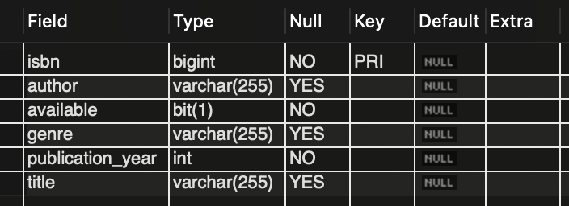

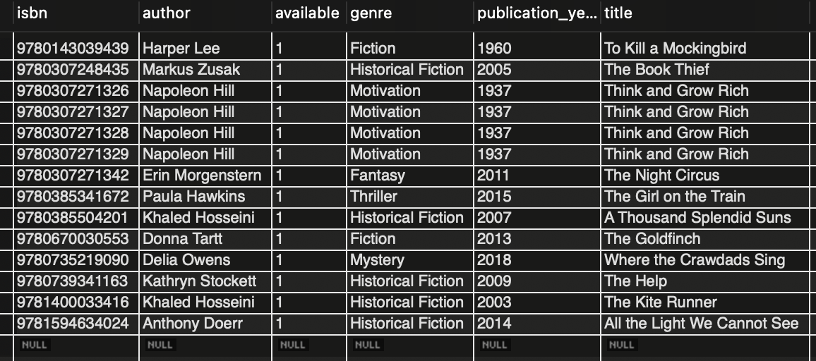

1. **Borrowers 5 points**
   * Each borrower has a unique ID, name, email, and contact number.
   * The system should maintain a record of the borrowing history for each borrower.

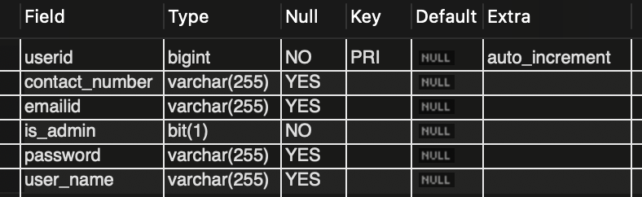

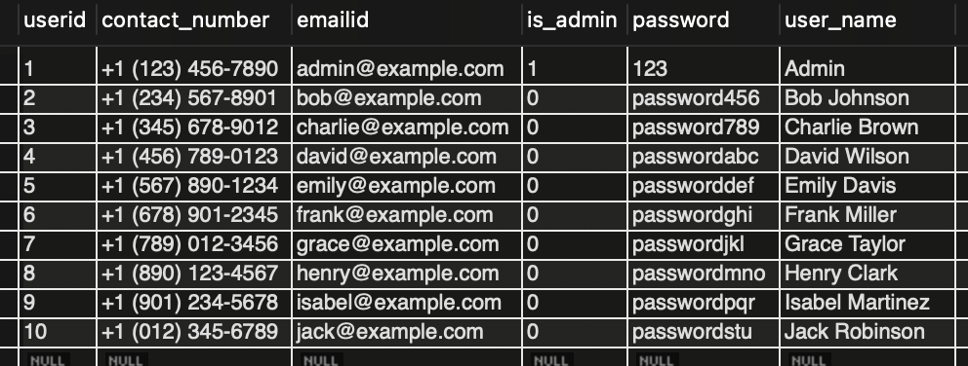

1. **Borrowing Transactions 5 points**
   * Each borrowing transaction should have a unique ID, borrower ID, book ISBN, and borrowing date.
   * The system should track the return date for each borrowed book.

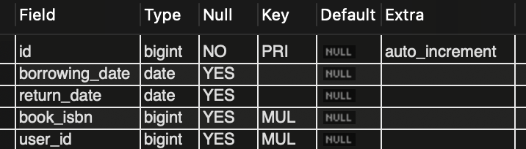

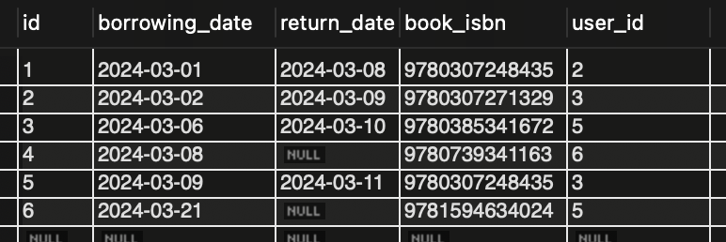

**Functionalities (implemented using a programming language):**

1. **Add Book 10 points**
   * Librarians should be able to add new books to the system, specifying details such as ISBN, title, author, genre, and publication year.
   * They should also be able to add multiple copies of the same book with different serial numbers.

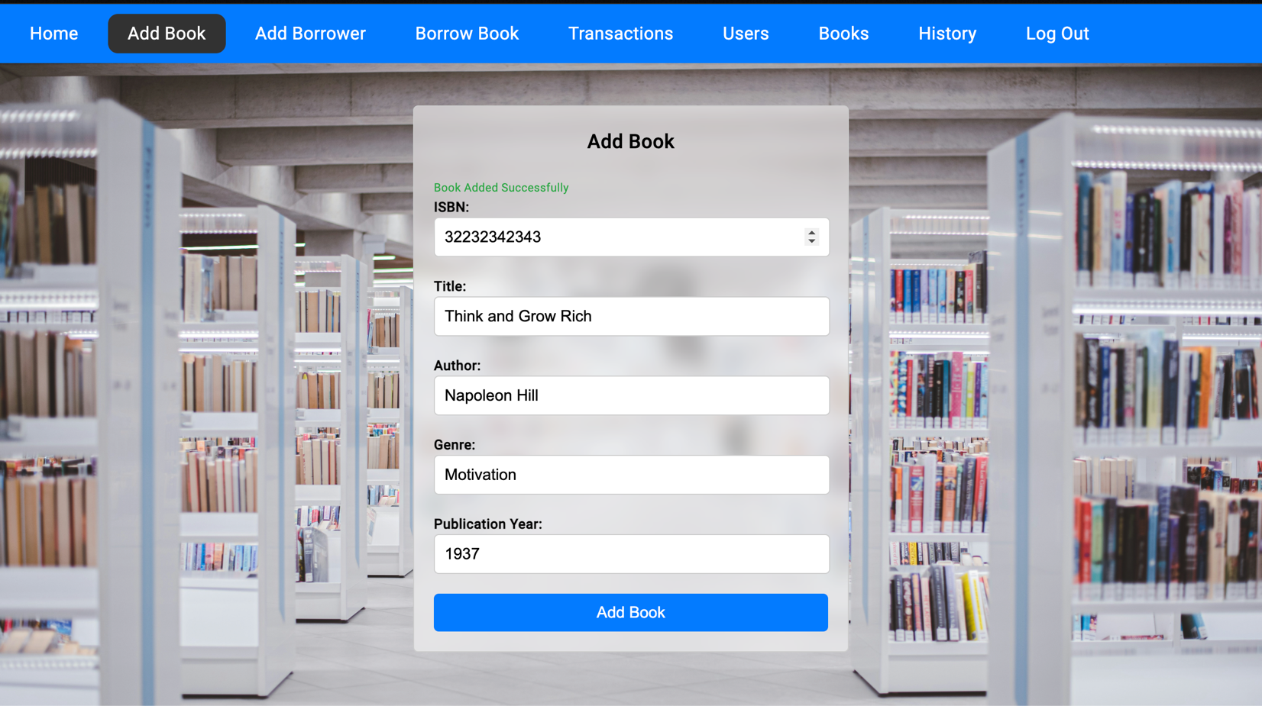

* The librarian can add books and it displays the message ‘Book Added Successfully’ when the book is added.

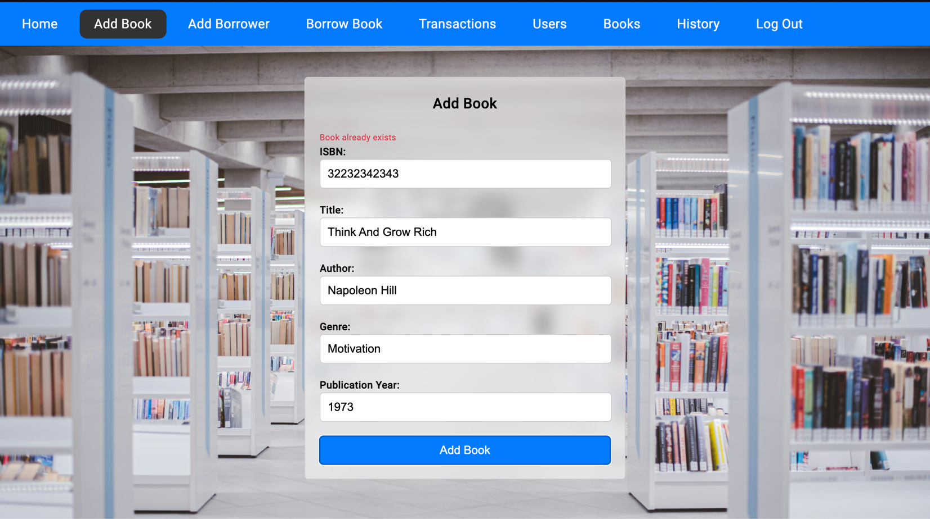

* Since the librarian is trying to add a book with the same ISBN that already exists, there is a message saying ‘Book already exists’. Because the ISB number is the primary key, it should be unique.

1. **Add Borrower 10 points**
   * Librarians should be able to add new borrowers to the system, providing details like name, email, and contact number.

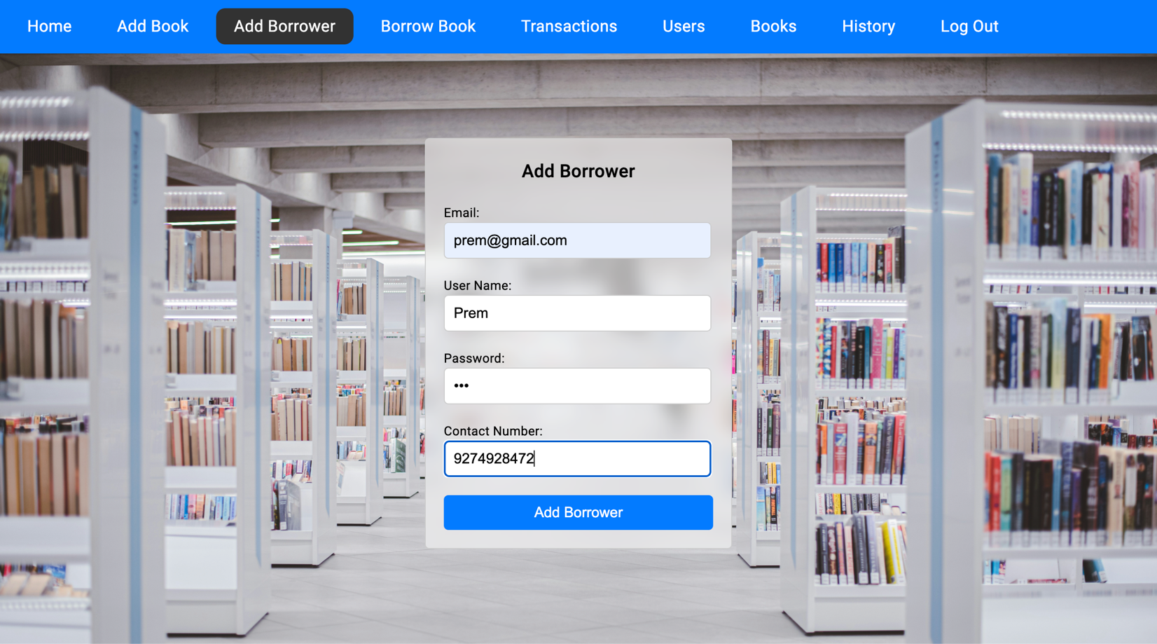

* The librarian can add borrowers by giving their details.
* All the details must be included to add the borrower.

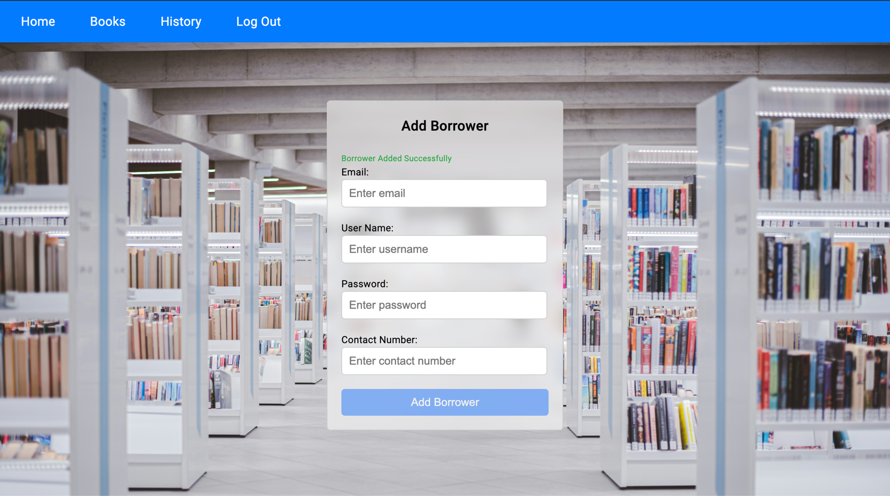

* Once the borrower is added it displays a message saying ‘Borrower Added Successfully’

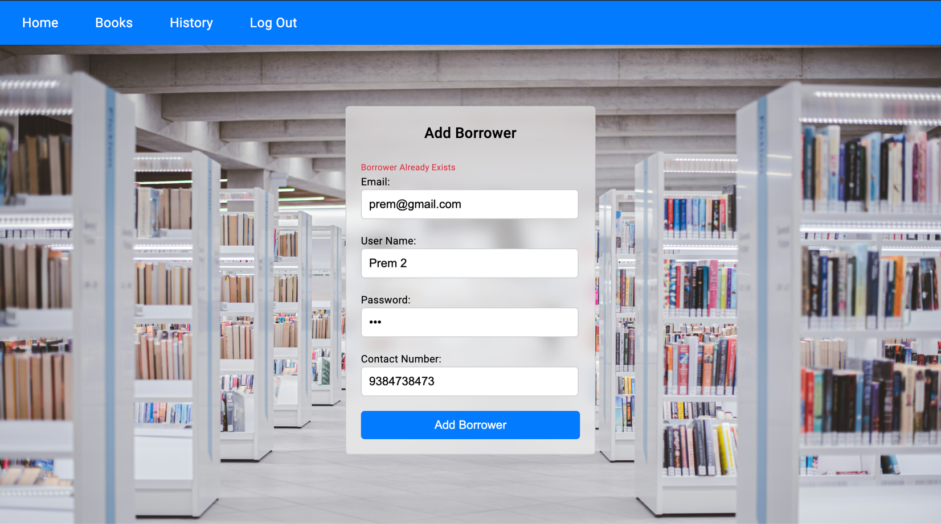

* If the borrower already exists, it displays an error message. Saying ‘Borrower already Exists’

1. **Borrow Book 15 points**
   * Librarians should be able to process borrowing transactions, recording the borrower ID, book ISBN, and borrowing date.
   * The system should update the availability status of the book copy accordingly.

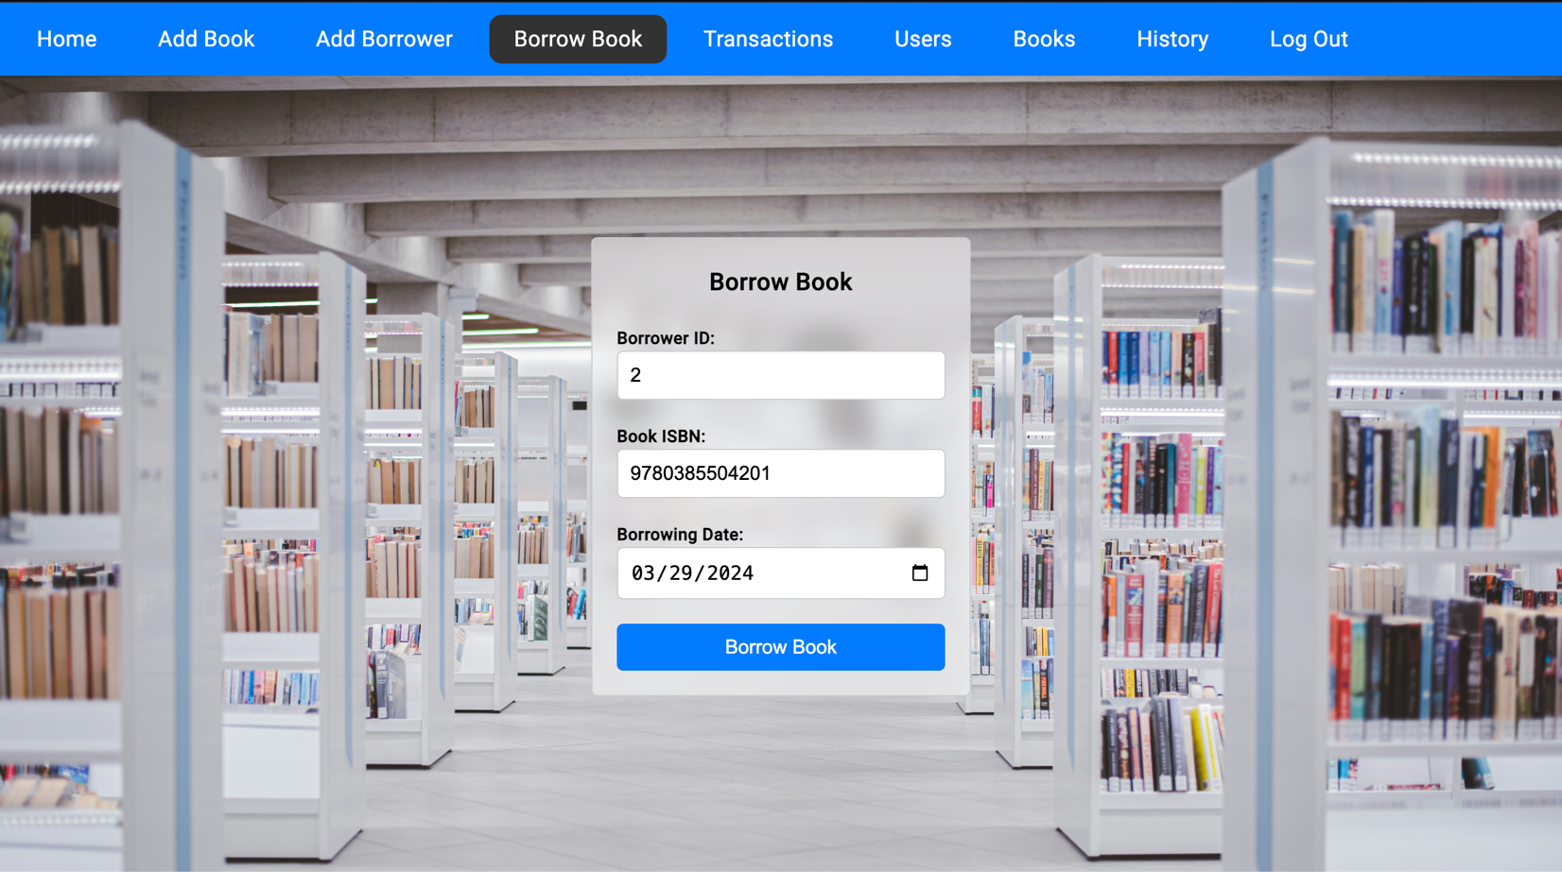

* The librarian can add a transaction, the above transaction means borrower 2 is borrowing a book with ISBN 9780385504201 on 03/29/2024.

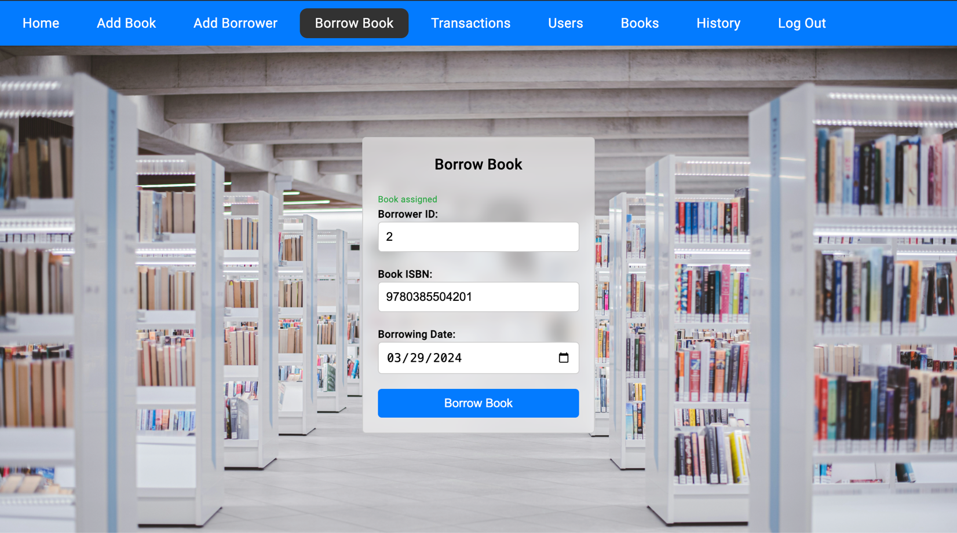

* Once the transaction is successful, it shows a message ‘Book assigned’,

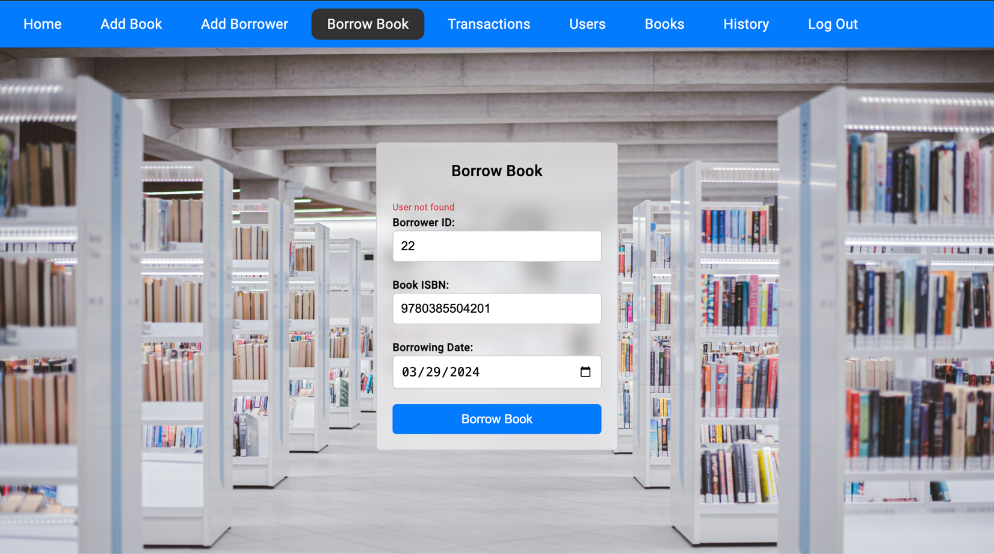

* If the borrower does not exist, it gives an error saying ‘User not found’

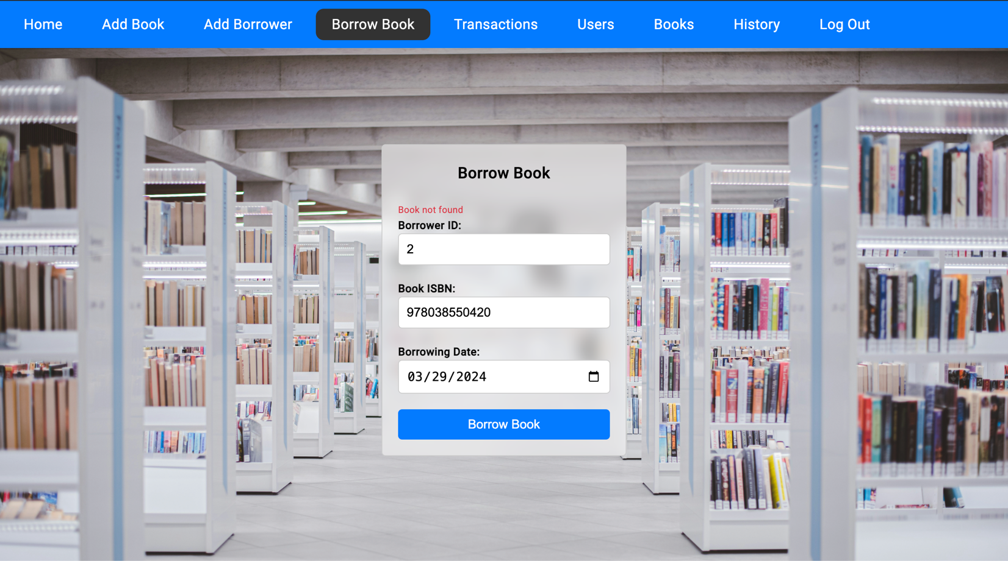

* If the book ISBN is not found then it gives an error message saying ‘Book not found’

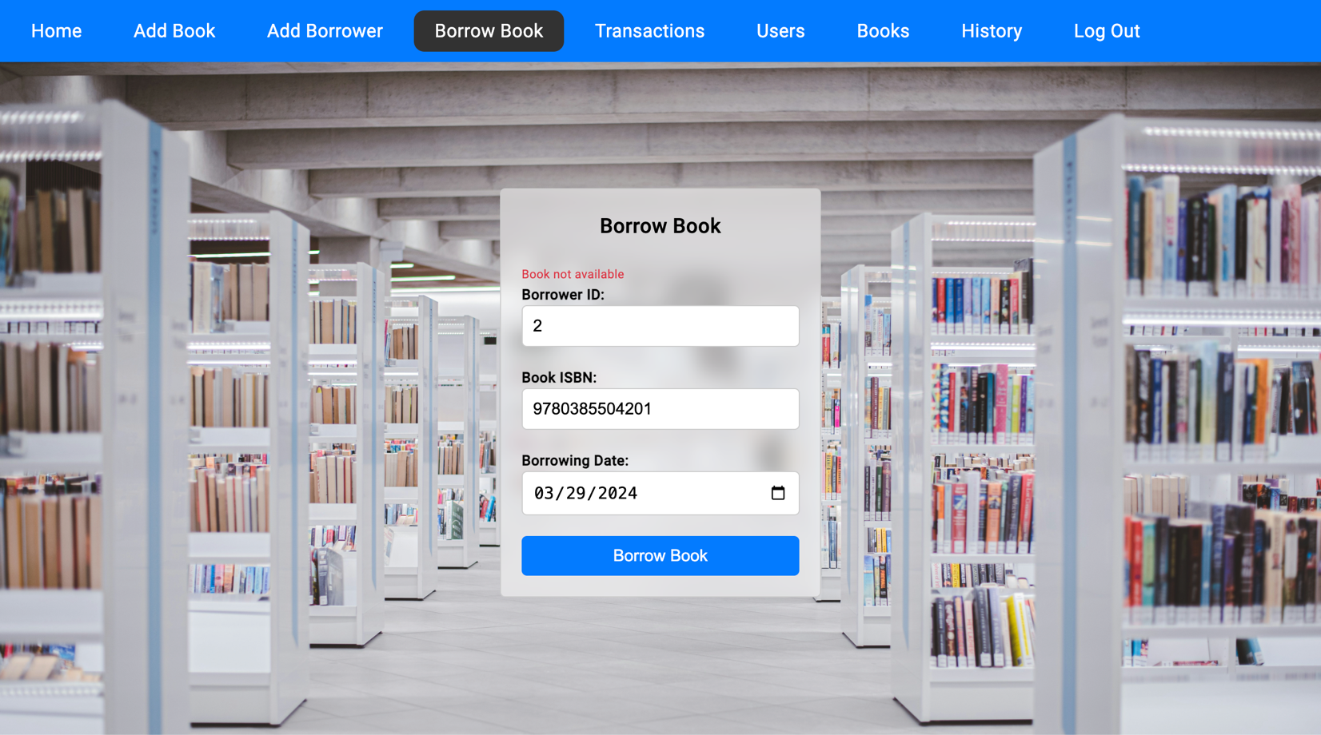

* If the book is already borrowed by some other user, then it gives an error saying, ‘Book not available’.

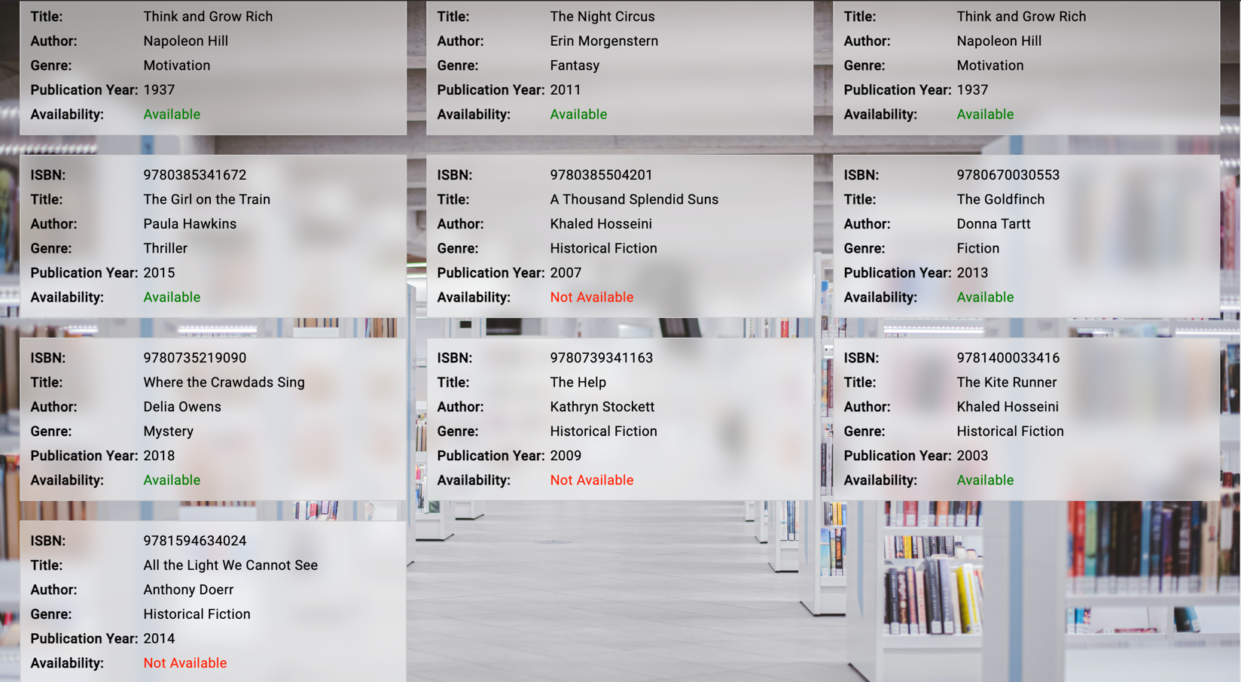

* Once the book I assigned to a borrower, the status of the book changed from ‘Available’ to ‘Not Available’.

1. **Return Book 15 points**
   * Librarians should be able to process return transactions, updating the return date for the borrowed book.
   * The availability status of the book copy should be updated accordingly.

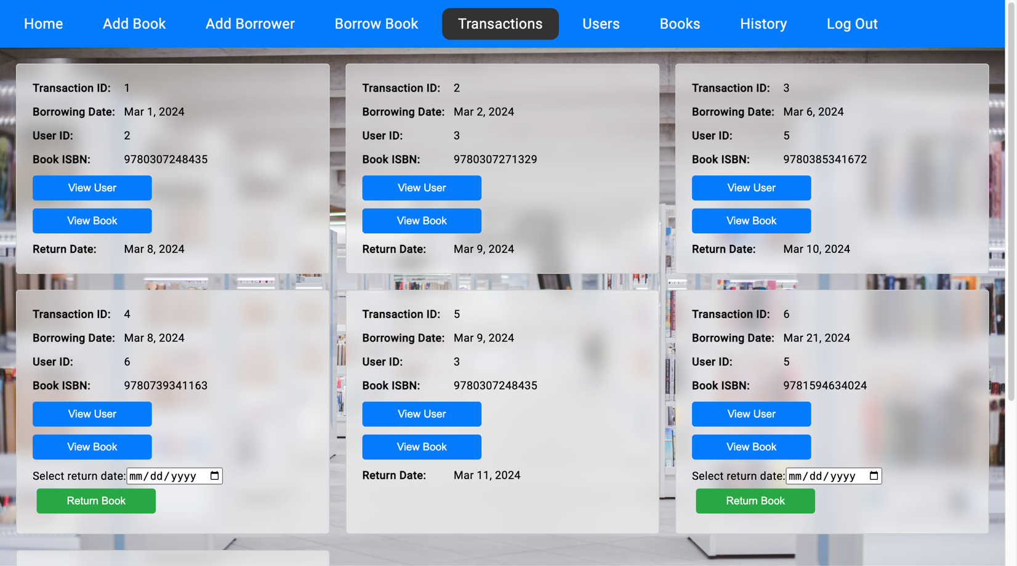

* The librarian can add a return date and take the book back from the borrower.

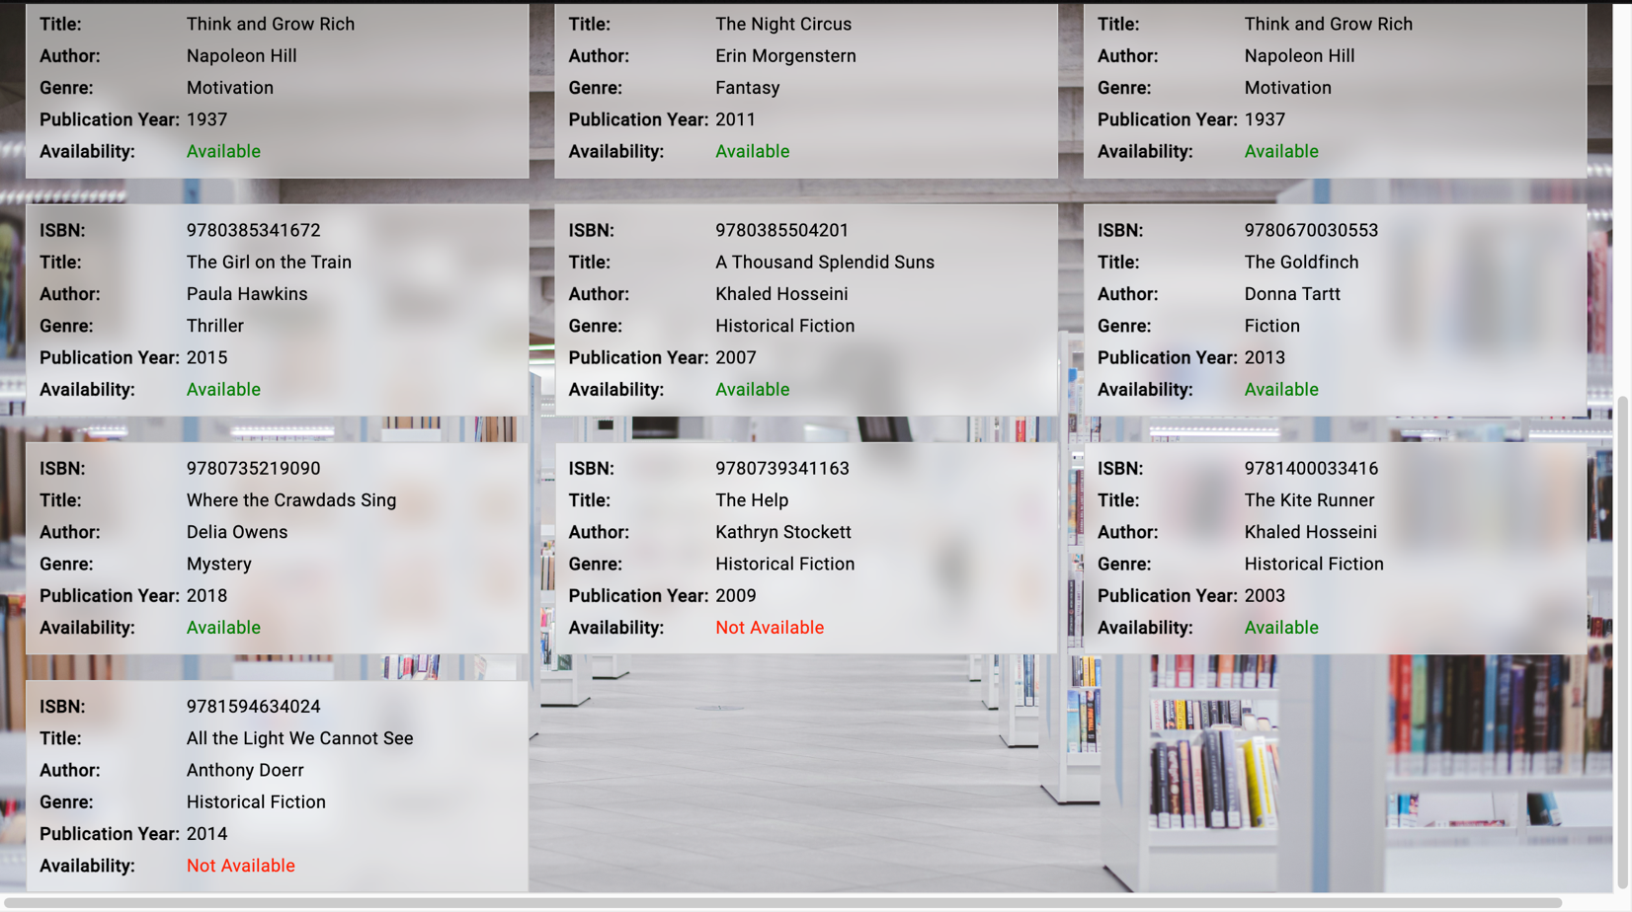

* Once the book is returned, the booking status gets updated from ‘Not Available’ to ‘Available’.

1. **Search Books 15 points**
   * Users should be able to search for books by ISBN, title, author, genre, or publication year.
   * The system should display all copies of the book along with their availability status.

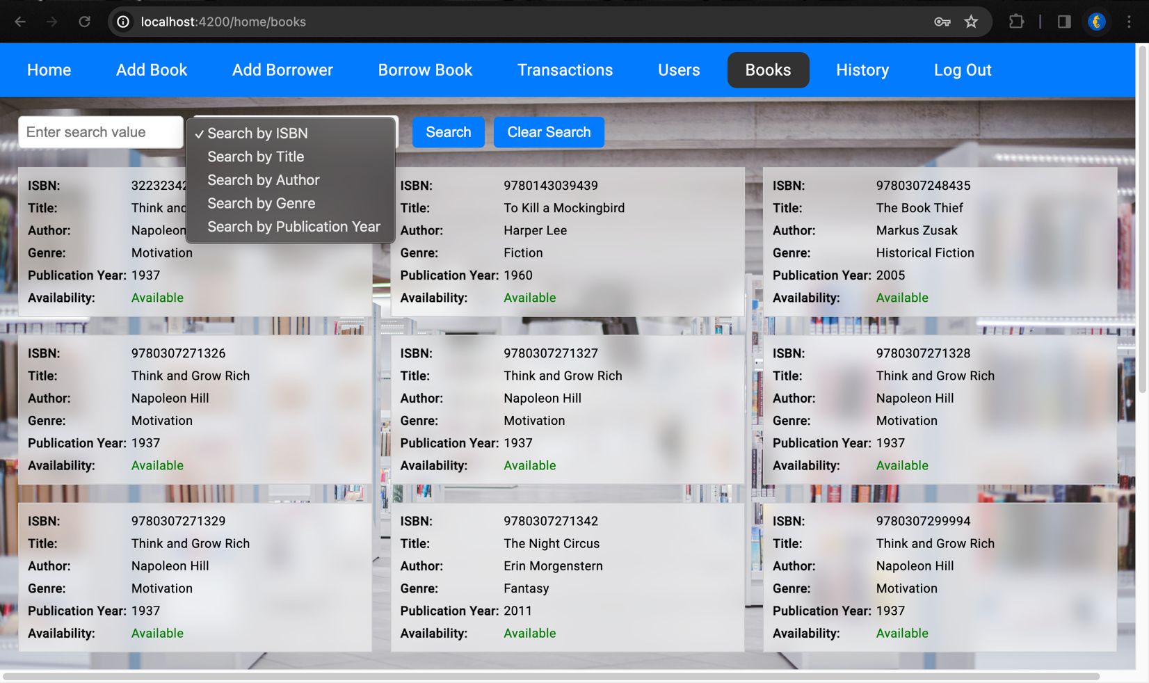

* Users and librarians can search books with various attributes like ISBN, Title, Author, Genre, and Publication Year.

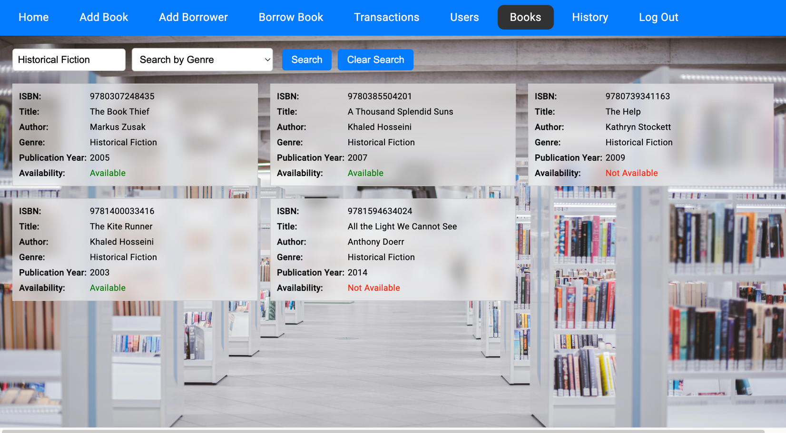

* It also displays the availability status of the book.

1. **View Borrowing History 5 points**
   * Users should be able to view the borrowing history of a specific borrower, listing all borrowed books along with their borrowing and return dates.

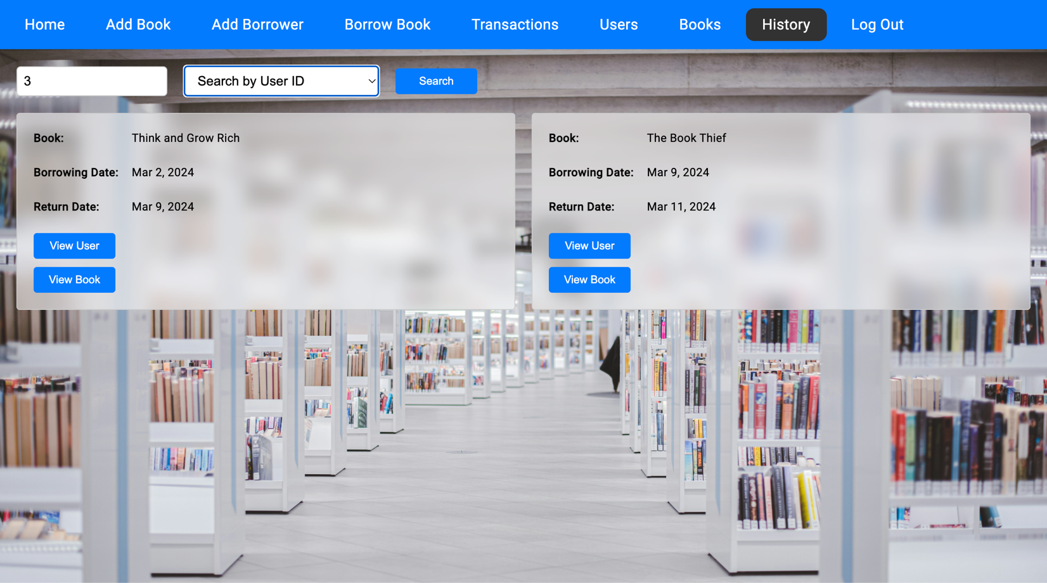

* Users and librarians can view the borrowing history of a specific borrower.

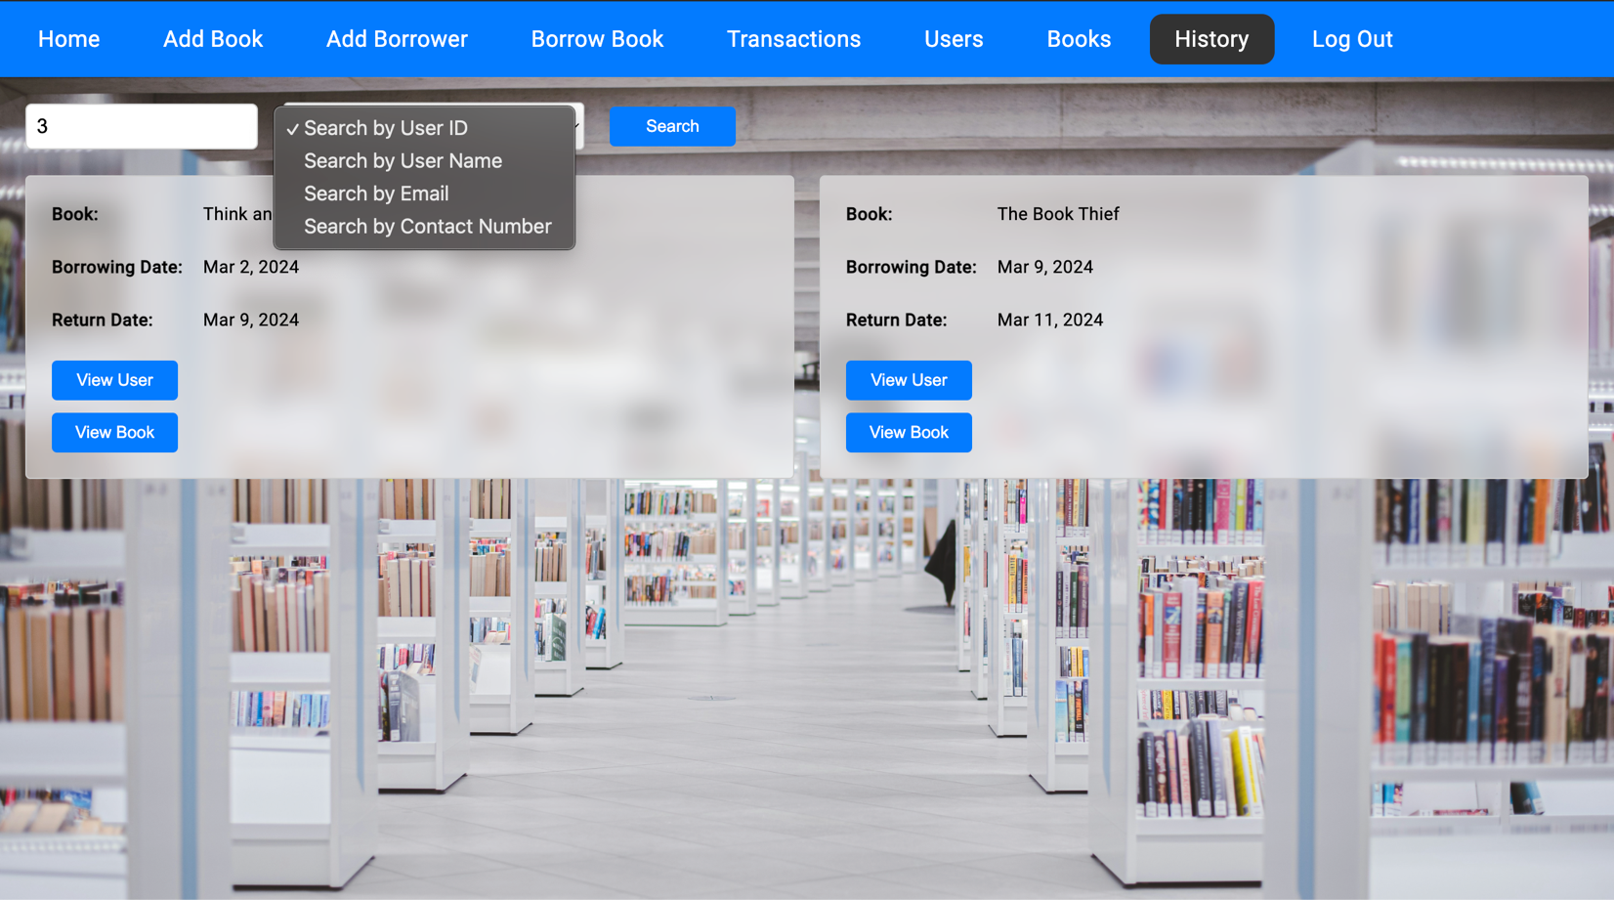

* The borrowing history can be checked by different attributes like user ID, User name, email, and Contact number.

1. **Additional:**

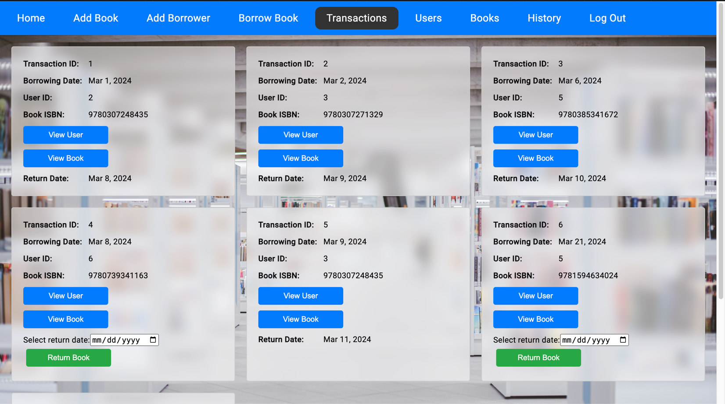

* Librarians can see all the transactions.

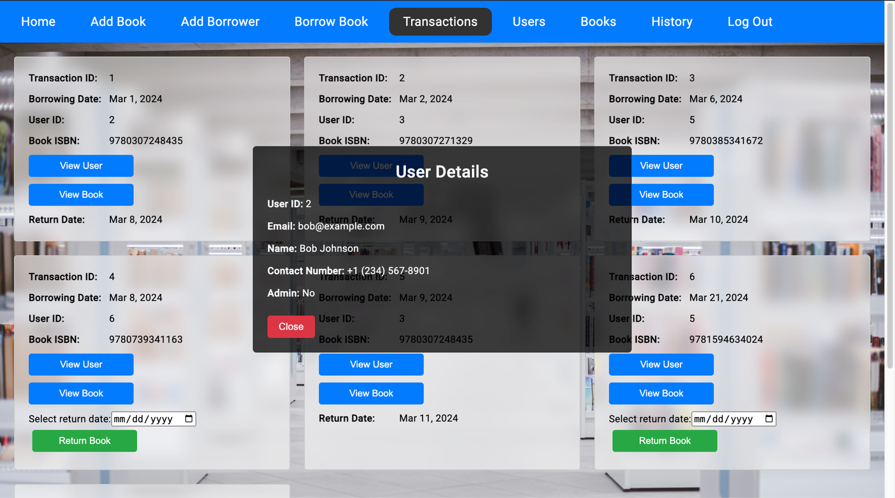

* The librarian can also see the user details for that particular transaction.

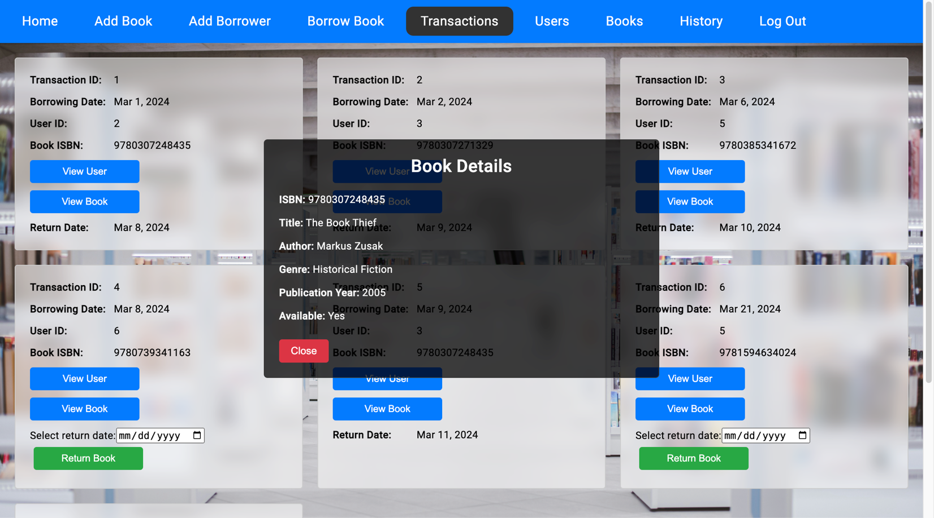

* The librarian can also see the book details for that particular transaction.

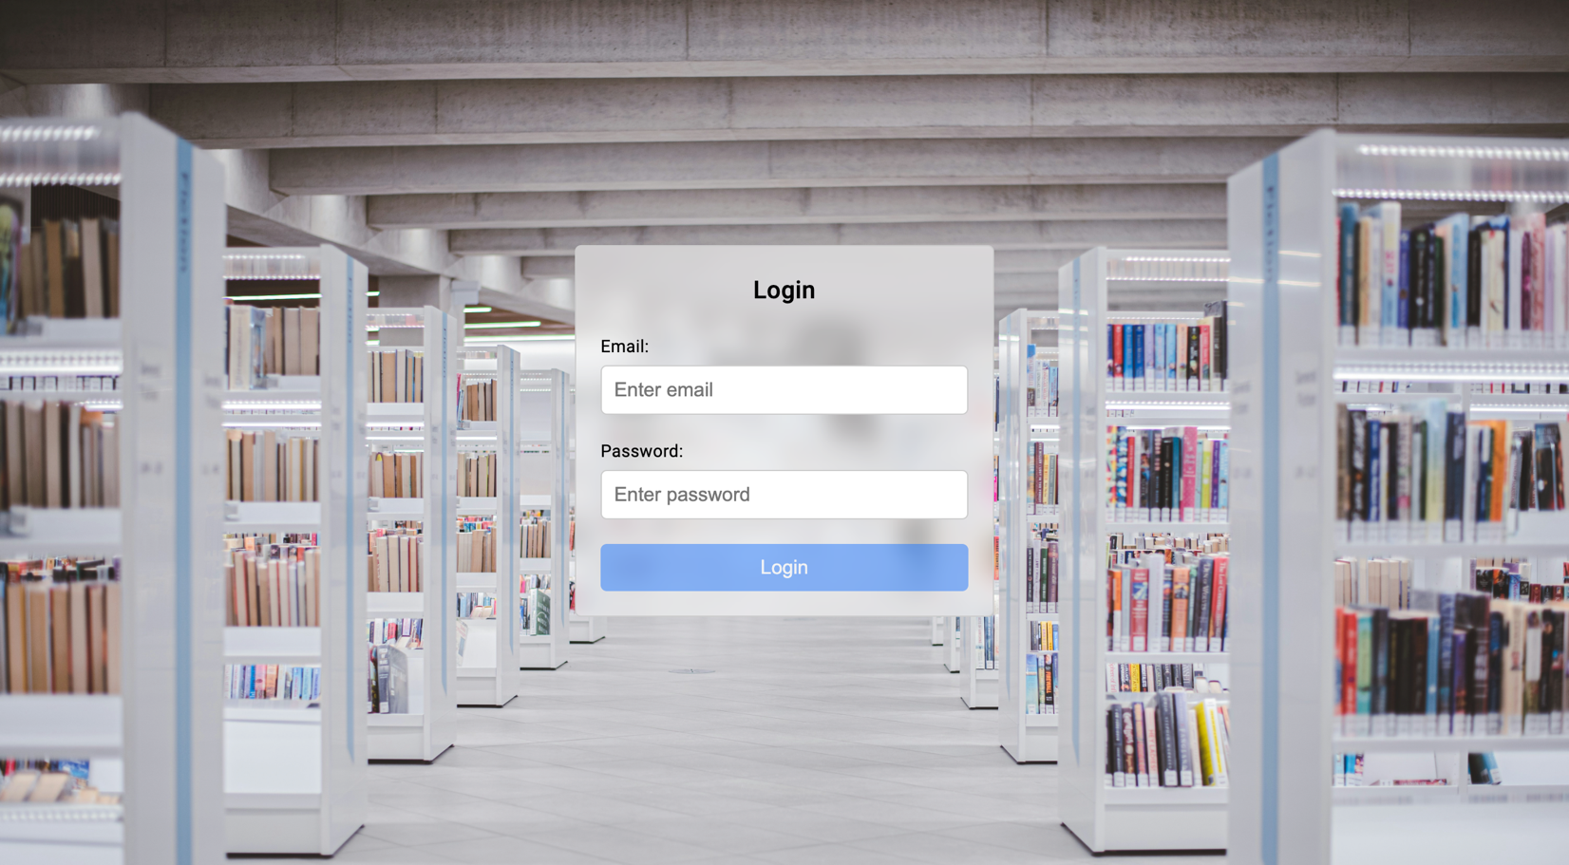

* The librarian and borrowers can log in using their email ID and password which were created by the librarian.

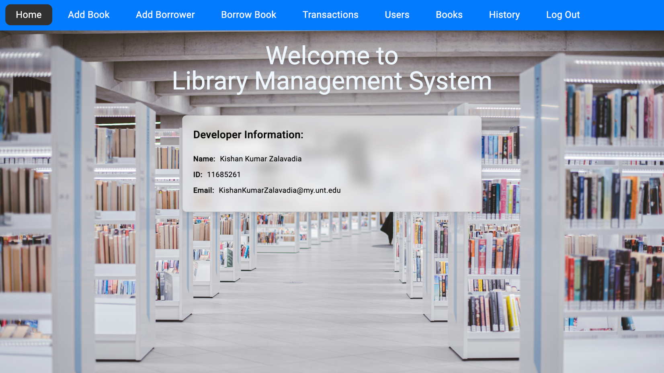

* The librarian can see all the various options like ‘Add Book’, ‘Add Borrower’, Borrow Book’, ‘Transactions’, ‘Users’, ’Books’, History’, and ‘Logout’.

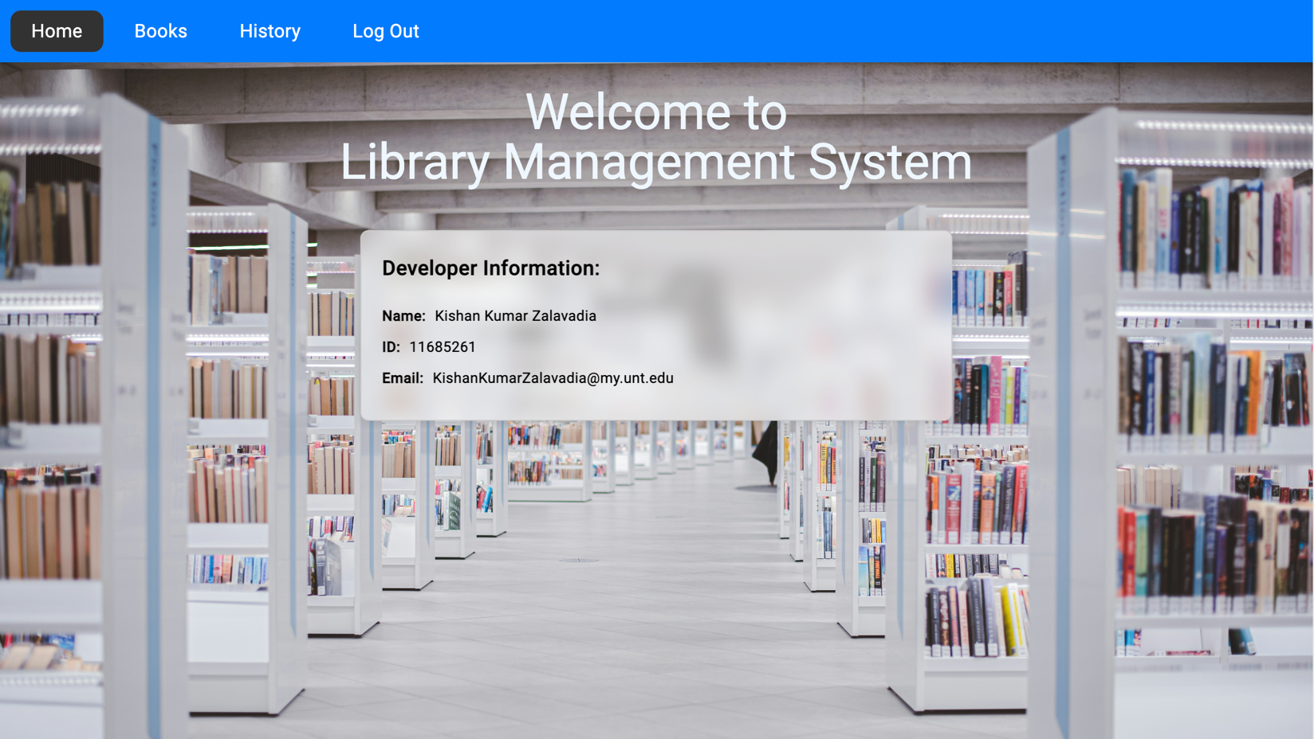

* The borrower has access to limited stuff like ‘Books’ (See all books), ‘History’ (Check the history of each user), And ‘Logout’.